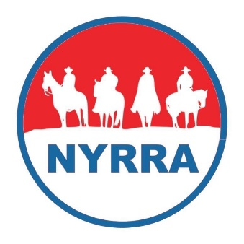

The National Youth Ranch Rodeo Association is a non-profit that exists to support youth ranch rodeo with aim at increasing opportunities for participation in the sport.
In 2025, the NYRRA will hold its two-day finals rodeo in Enid, Oklahoma at the Chisolm Trail Expo Center on July 27th and 28th. The finals will be held in an indoor arena with a prize banquet and dinner to follow. We work hard to ensure all contestants receive great prizes with saddles going to champion teams.
To qualify for NYRRA finals, a team of four must attend 5 sanctioned rodeos and each member purchase a $175 membership card. The age cutoff is August 5th, 2024. Teams are allowed to use up to two subs at a sanctioned rodeo and the rodeo still be a qualifying rodeo (see rulebook).
We have included an agreement form that outlines sanctioning details. Sanctioned rodeos are obligated to send the NYRRA $75/rodeo OR secure a Bronze level sponsorship ($400) for the NYRRA. The sponsorship can come from a business or from the sanctioned association with a check payable to the NYRRA (see our Sponsorship Form for more details). Sanctioned rodeos will collect the $10 NYRRA entry fee from NYRRA contestants and submit it online or mail a check to our secretary (these fees, as well as membership and sanctioning fees go toward purchasing prizes at the finals).
If your club/association/family is interested in hosting one or several NYRRA sanctioned rodeos, please reach out at sgarrett@nyrra.org. We do all we can to support you in your endeavor, including promotion of your event to our members. Please submit the online sanctioning agreement or mail us the following sanctioning agreement. You will be notified of approval within 10 business days of us receiving your application.
Feel free to call us with questions at 580-716-2771.

NYRRA SANCTIONED RODEO AGREEMENT/APPLICATION
Name of Association or individual/s putting on rodeo/s:

Date/s:

Location:

We agree that our event will be covered at a minimum with $1,000,000 liability insurance.
We understand that the last rodeo of the 2024/2025 season can be held no later than July 13th, 2025 and that no NYRRA contestant memberships will be approved after May 1st.
We understand that our event can be no closer than 50 miles to another previously scheduled NYRRA sanctioned rodeo during the same weekend.
We understand that we may produce no more than two sanctioned rodeos within 50 miles of an already established NYRRA sanctioned association that will hold 5 or more rodeos in a given season.
We agree to mail a $75/rodeo sanctioning fee to the NYRRA OR to securing a $400 Bronze level sponsorship for the NYRRA (this will cover the sanctioning fee for the entire season).
We agree that monies collected for NYRRA sanctioned teams will be submitted online or mailed by check to the NYRRA secretary within 14 days of the rodeo. ALL PAYMENTS FOR JULY RODEOS MUST BE POSTMARKED BY JULY 7TH OR PAID ONLINE BY JULY 14TH.
We understand that we must use the 2024/2025 NYRRA Event Rules and Age Divisions.
We agree to not hold the NYRRA liable for any incident that occurs at our NYRRA sanctioned event.
We agree that all contestants participating in the rodeo will sign an injury waiver.

Signature of Rodeo Official Date

Printed Name
If you prefer to mail this from rather than fill it out online, please send to:
NYRRA
5151 West County Line Road, Ponca City, OK 74601

